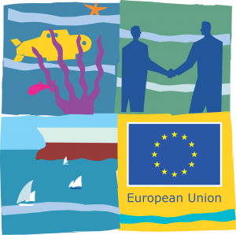
EUROPEAN MARITIME DAY 2012

MARINE AND MARITIME INNOVATION IN THE OUTERMOST REGIONS
BLUE GROWTH AND SMART SPECIALISATION
Gothenburg, 22 May, 10:00-11:30, room K40

EU Outermost Regions have a high potential in maritime activities and marine research as their large maritime areas provide ecosystems of considerable interest.
This workshop will showcase on-going and foreseen projects and initiatives conceived to fully embrace the natural and unexplored potential of these regions as gateway to the sea and beyond it to the wilder world.
Outermost Regions seek to demonstrate how their strengths and comparative advantages can be exploited at the EU level and why their assets should be placed at the core of Maritime Policy.

Chair:
Rodrigo OLIVEIRA – Undersecretary for European Affairs and External Cooperation of the Regional Government of the Azores, on behalf of the President of the Conference of the Outermost Regions

Speakers:
Frédéric CADET - Vice-President in charge of International Relations, Cooperation, Innovation and Research – Réunion Regional Council

Marimar VILLAGARCIA – MaReS, PLOCAN Consortium - Canary Islands

Jean CRUSOL – President of the Economic Affairs Commission - Martinique Regional Council

Jessica JULAN-AUBOURG – Head of Service on Fisheries – Guadeloupe Regional Council

Frederico CARDIGOS - Regional Director for Sea Affairs – Regional Government of the Azores

Bernhard FRIESS - Director for the Atlantic, Outermost Regions and Arctic – European Commission

